Python Assignment

(University name)

Name

**Activity 1**

A variable is a symbolic name used to store data in coding to manipulate data. It is like a container for data.

Data types are the definition of the value category saved in a variable. For example, the variable “studentName” is a data type of string. “studentIndexNumber”, “numberOfSubjects” are two variables with data type of integer. The “subjectMark” is a variable with List data type.

**Activity 2**

List

List is a data type used to store collection of data. We can use a List in this scenario to store the subject data collection entered by the user. The items in the List are ordered according to the order they are appended. Elements inside the List can be accessed through index.

List is mutable. We can create new List, append new List item, change existing item or remove an item. A single List can contain multiple different data types. They can grow or shrink unlimitedly. List is expressed using brackets []. The items in the list are separated with a comma.

Tuple

Tuple is same as List. It contains a collection of data which are separated by commas. The difference is unlike Lists, Tuples are immutable. Which means the elements in the tuple can not be changed after initialization. Tuples are created using ().

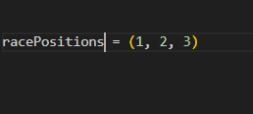

For a single tuple, a comma is required

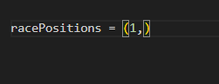

Tuples are accessed in the same way the arrays are accessed.

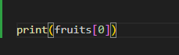

Dictionary

A dictionary is a variable where the data is stored as key – value pair. They are mutable. The Keys are immutable. They can grow and evolve to unlimited sizes. Dictionaries are initialized with {}

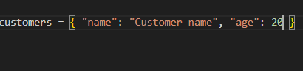

Accessing a data is same as the array. Only difference we have to use the key, instead of the index to access the value.

